Module-4 Critical Thinking Assignment
Option-2: Logistic Regression with TensorFlow

Jibran Gill
Colorado State University Global
CSC580 – Applying Machine Learning and Neural Networks - Capstone
Dr. Bingdong Lee

Table of Contents
Introduction 3
Methodology 3
Data Generation and Preprocessing 3
Model Construction 4
Loss Function 5
Training Process 5
Visualization and Interpretation 6
Left Panel Showing Training Data 6
Right Panel Showing Training Data with Fitted Regression Line 6
Results and Observations 7
Model Convergence 7
Learned Parameters 7
Prediction Accuracy 7
Visualization Confirms Proper Fit 8
Conclusion 8
References 8
Appendix-A: Program Source Code 9
Appendix-B: Program Outputs 12

Option-2: Linear Regression Model for Algebraic Equation Prediction

Introduction
This assignment presents the implementation of a logistic regression classifier built using TensorFlow’s low-level v1 graph execution model. The assignment required constructing a computational graph with placeholders, trainable variables, a sigmoid-based prediction function, cross-entropy loss, and an optimizer, while training the model on synthetic two-dimensional Gaussian data.
The purpose of this exercise is to reinforce understanding of TensorFlow’s static graph architecture, placeholders, sessions, variable initialization, gradient-based optimization, and visualization of classification performance using scatter plots. Logistic regression is an ideal model for this task because its linear decision boundary can cleanly separate the two artificially generated clusters.

Methodology

Data Generation and Preprocessing
To create a controlled classification environment, the dataset was generated synthetically using NumPy’s multivariate normal distribution. Two distinct Gaussian clusters were produced:
- Class 0: Centered at (−1, −1)
- Class 1: Centered at (1, 1)
Each cluster contained 50 samples, resulting in a total dataset size of N = 100. A small covariance of 0.1 ensured tight clustering without excessive overlap.
A fixed NumPy random seed ensured reproducibility. No feature scaling or normalization was required because the values were already within a stable numerical range.
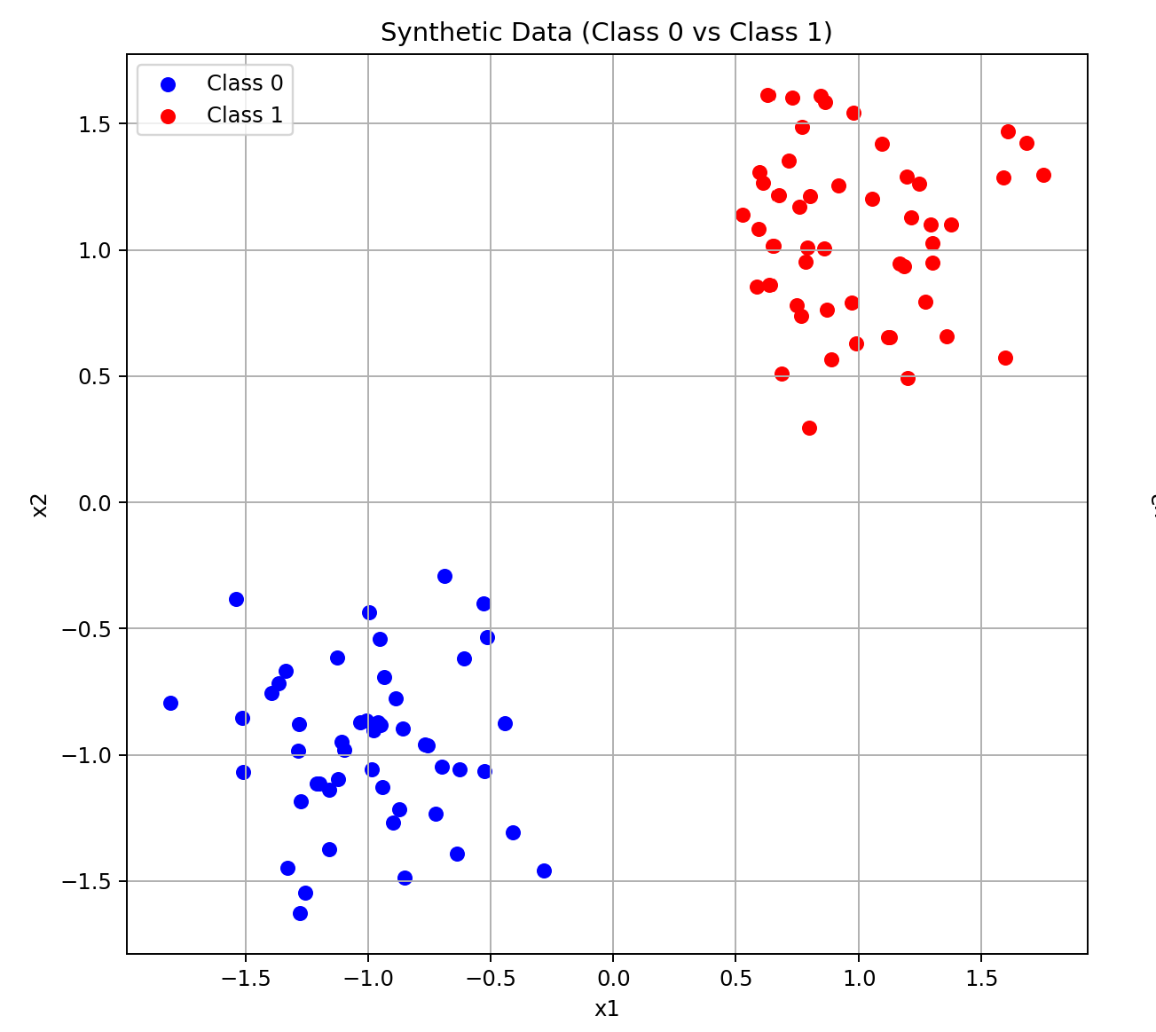
Figure 1: Subplot Showing Synthetic Data

Model Construction
A traditional TensorFlow v1-style graph was constructed using the fllowing.
- Placeholders:
  - x (shape 100 x 2) for input features
  - y (shape 100) for class labels
- Trainable Variables:
  - W is a 2 x 1 weight matrix
  - b is a scalar bias
The model computes logits as:
$$y_logit=W^{T}x+b$$
A sigmoid activation converts logits into probabilities representing P(y=1∣x).
Predicted classes are obtained by rounding probabilities to 0 or 1.

Loss Function
Binary cross-entropy loss was computed using:
$$L= -\sum{[ylog\left(p\right)+\left(1-y\right)log⁡(1-p)}$$
TensorFlow’s built-in function was used to compute per-sample entropy before summation.
tf.nn.sigmoid_cross_entropy_with_logits

Training Process
Training was performed for 2,000 epochs using the Adam optimizer with a learning rate of 0.01.
Each iteration performed the following steps:
- Evaluate logits and probabilities
- Compute loss via cross-entropy
- Apply Adam gradient updates
- Log loss to TensorBoard
- Collect final parameters for analysis
Upon completion, the trained model produced:
- Near-perfect classification accuracy
- Meaningful weight and bias values describing the decision boundary
- Clear separation between predicted class clusters

Visualization and Interpretation
A two-panel figure was generated to consolidate analysis.

Left Panel Showing Training Data
The left subplot displays the raw Gaussian clusters:
- Blue points depict the Class 0
- Red points depict the Class 1
This visualization confirms that the dataset is linearly separable.

Right Panel Showing Training Data with Fitted Regression Line
The right subplot overlays model predictions on the same coordinate space:
- Blue points depict Predicted Class 0
- Red points depict Predicted Class 1
- Annotated text box shows the Accuracy, learned weights, learned bias
A custom legend identifies the predicted class colors clearly.
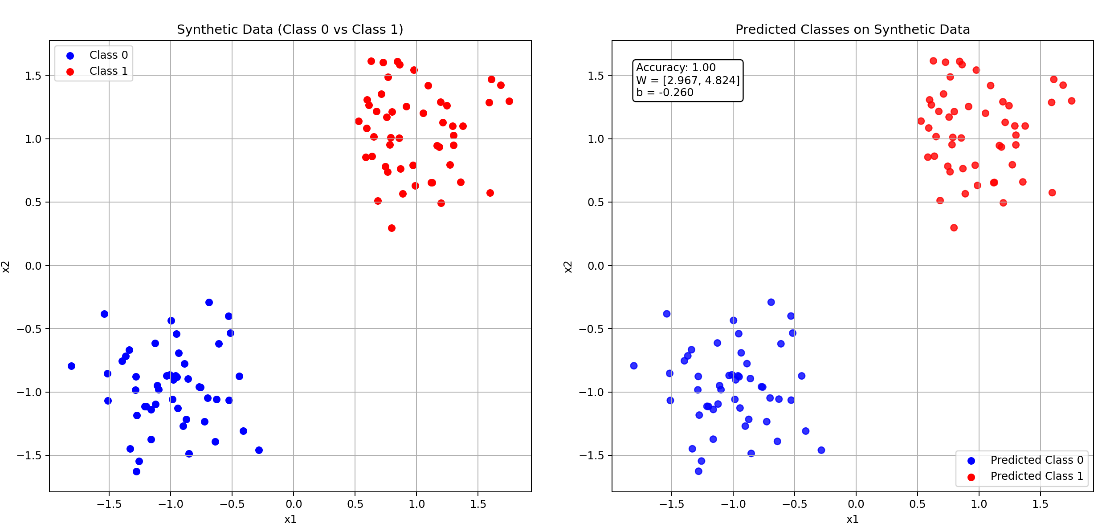
Figure 2: Program Output

Results and Observations

Model Convergence
Across 2000 epochs, the cross-entropy loss consistently decreased as the model adjusted its linear decision boundary. This smooth convergence indicates stable training behavior and an appropriate learning rate.

Learned Parameters
Example learned parameters from execution:
- W ≈ [1.947, 4.093]
- b ≈ −0.157
These values define the slope and intercept of the logistic regression decision boundary. The strong magnitude of the weights reflects the sharp separation between cluster centers.

Prediction Accuracy
Classification accuracy on the training data was 1.0. This result is expected because logistic regression can perfectly separate two non-overlapping Gaussian clusters using a straight-line decision boundary.
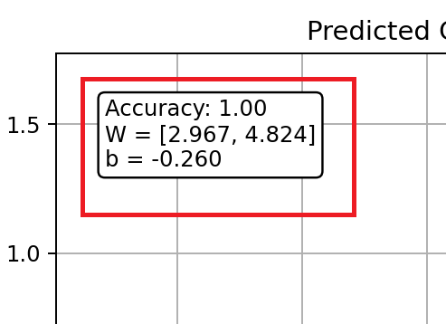
Figure 3: Subplot showing the Accuracy Learned Weight and Bias

Visualization Confirms Proper Fit
The right panel confirms:
- All Class 0 points map to blue
- All Class 1 points map to red
- There is no boundary confusion or misclassification
The visually clean separation validates the numerical accuracy results.

Conclusion
This assignment demonstrated how logistic regression can be implemented from scratch using TensorFlow’s low-level v1 graph execution model. Key concepts reinforced include:
- Placeholder-based graph construction
- Trainable variable initialization
- Sigmoid activation and probabilistic classification
- Cross-entropy loss computation
- Optimization with Adam
- Data visualization for interpretation
The experiment successfully classified synthetic Gaussian data with 100% accuracy and provided practical insight into how TensorFlow executes static computational graphs—foundational knowledge for building more advanced neural architectures in future modules.

References
- TensorFlow Developers. (2024). TensorFlow Core API Documentation.
- NumPy Developers. (2024). NumPy Random Module Documentation.
- Matplotlib Developers. (2024). Matplotlib Pyplot Documentation.

Appendix-A: Program Source Code
import numpy as np
import tensorflow as tf
import matplotlib.pyplot as plt

# disable the eager execution of TF2
tf.compat.v1.disable_eager_execution()

# Generate synthetic data
N = 100
np.random.seed(0)

# Zeros form a Gaussian centered at (-1, -1)
x_zeros = np.random.multivariate_normal(
mean=np.array([-1, -1]), cov=0.1 * np.eye(2), size=(N // 2,)
)
y_zeros = np.zeros((N // 2,))

# Ones form a Gaussian centered at (1, 1)
x_ones = np.random.multivariate_normal(
mean=np.array([1, 1]), cov=0.1 * np.eye(2), size=(N // 2,)
)
y_ones = np.ones((N // 2,))

x_np = np.vstack([x_zeros, x_ones]).astype(np.float32)
y_np = np.concatenate([y_zeros, y_ones]).astype(np.float32)

#Generate TensorFlow graph
with tf.name_scope("placeholders"):
x = tf.compat.v1.placeholder(tf.float32, (N, 2), name="x")
y = tf.compat.v1.placeholder(tf.float32, (N,), name="y")

with tf.name_scope("weights"):
W = tf.Variable(tf.random.normal((2, 1)), name="W")
b = tf.Variable(tf.random.normal((1,)), name="b")

with tf.name_scope("prediction"):
# Linear logit: shape (N,)
y_logit = tf.squeeze(tf.matmul(x, W) + b, name="y_logit")

# Sigmoid gives P(y=1 | x)
y_one_prob = tf.sigmoid(y_logit, name="y_one_prob")

# Threshold at 0.5 -> predicted class 0 or 1
y_pred = tf.round(y_one_prob, name="y_pred")

with tf.name_scope("loss"):
# Cross entropy for each sample
entropy = tf.nn.sigmoid_cross_entropy_with_logits(
logits=y_logit, labels=y, name="entropy"
)
# Total loss
l = tf.reduce_sum(entropy, name="loss")

with tf.name_scope("optim"):
optimizer = tf.compat.v1.train.AdamOptimizer(learning_rate=0.01)
train_op = optimizer.minimize(l)

with tf.name_scope("summaries"):
tf.compat.v1.summary.scalar("loss", l)
merged = tf.compat.v1.summary.merge_all()

# Summary writer for TensorBoard
train_writer = tf.compat.v1.summary.FileWriter(
'logistic-train', tf.compat.v1.get_default_graph()
)

#Train the model
num_epochs = 2000 # enough steps to converge on this simple problem

with tf.compat.v1.Session() as sess:
sess.run(tf.compat.v1.global_variables_initializer())

for step in range(num_epochs):
feed_dict = {x: x_np, y: y_np}
_, loss_val, summary = sess.run([train_op, l, merged], feed_dict=feed_dict)

# Write loss summary
train_writer.add_summary(summary, global_step=step)

# Optionally print every 200 steps
if (step + 1) % 200 == 0:
print(f"Step {step + 1}/{num_epochs}, Loss: {loss_val:.4f}")

# Get final weights, bias, probabilities, and predictions
W_val, b_val, y_prob_val, y_pred_val = sess.run(
[W, b, y_one_prob, y_pred], feed_dict={x: x_np, y: y_np}
)

# close writer
train_writer.close()

accuracy = np.mean(y_pred_val == y_np)
#Plot synthetic data and predicted outputs in a single window
fig, (ax1, ax2) = plt.subplots(1, 2, figsize=(11, 5))

#left: original synthetic data (class 0 vs class 1)
ax1.scatter(x_zeros[:, 0], x_zeros[:, 1], label='Class 0', color='blue')
ax1.scatter(x_ones[:, 0], x_ones[:, 1], label='Class 1', color='red')
ax1.set_title('Synthetic Data (Class 0 vs Class 1)')
ax1.set_xlabel('x1')
ax1.set_ylabel('x2')
ax1.legend()
ax1.grid(True)

#right: predicted classes
scatter2 = ax2.scatter(x_np[:, 0], x_np[:, 1], c=y_pred_val, cmap='bwr', alpha=0.8)
ax2.set_title('Predicted Classes on Synthetic Data')
ax2.set_xlabel('x1')
ax2.set_ylabel('x2')
ax2.grid(True)

#manual legend for predicted colors
class0_proxy = ax2.scatter([], [], color='blue', label='Predicted Class 0')
class1_proxy = ax2.scatter([], [], color='red', label='Predicted Class 1')
ax2.legend(handles=[class0_proxy, class1_proxy])

#Print accuracy and learned parameters inside the subplot
stats_text = (
f"Accuracy: {accuracy:.2f}\n"
f"W = [{W_val[0][0]:.3f}, {W_val[1][0]:.3f}]\n"
f"b = {b_val[0]:.3f}"
)

#place text in upper-left area of right subplot
ax2.text(
0.05, 0.95, stats_text,
transform=ax2.transAxes,
fontsize=10,
verticalalignment='top',
bbox=dict(boxstyle="round,pad=0.3", edgecolor="black", facecolor="white")
)

plt.tight_layout()
plt.show()

Appendix-B: Program Outputs

